Dear X
I wanted to let you know about our draft plans to bring hundreds of highly skilled and well-paid jobs to the Welsh Valleys through the construction of a glass container manufacturing facility within the Rassau Industrial Estate in Ebbw Vale. This not only has the potential to be one of the largest single investments in Wales for some considerable time but can also provide economic benefits for generations to come.
Our plans are now at an advanced and an important stage. An Environmental Impact Assessment Study was submitted at the end of April to the local Council while a delegation of local leaders has visited our existing glass production facilities in Turkey.
Ciner Glass intends to make a positive and long-term contribution to the future of Wales. We want to work constructively in partnership with the Welsh and UK Governments as well as other relevant stakeholders in the Valleys and across Wales. The hope is that the size and scale of this project can act as a catalyst to provide further innovation and investment to this area.
Our company
Ciner Glass is a family business, headquartered in London and is 100% owned by the Ciner Group, a major international conglomerate based in Turkey. This project would be our biggest investment outside Turkey so far and is part of a significant expansion programme across Europe and the USA. We are also the world’s number one producer of natural soda ash, a key raw material in the production of glass.
If this proposal receives the necessary approval, Ciner Glass intends to supply glass bottles to UK food and beverage producers. We already produce some of the lightest bottles in the world which reduces transportation costs. We believe South Wales is well positioned to serve the existing UK operations of our customers. We think it is important to cut the number of miles bottles have to travel to reach the customer. Our vision is to build a centre of engineering excellence in glass technology here in Wales which can compete with the best in the world.
Economic benefits
Ciner Glass is committed to providing training and employment opportunities for local people. Our preferred strategy is to employ young people from the local community who do not have preconceived ideas about ‘old fashioned’ glass manufacturing.
Ciner Glass wants to hire people with open minds to whom we can share our values of working together as a family. We are proud of the intensive training and development programme we have created with our partners in Turkey and we will seek to replicate that in Wales.
Environmental impact
Our plans for a new glass production facility can be integrated with the Welsh and UK Government’s vision for a sustainable, low-carbon circular economy. We also want to play our part in ensuring Wales is an acknowledged world leader in recycling. Glass is environmentally friendly and fully-recyclable.
We are committed to sustainable production and improving the environment in everything we do. We support plans for a Deposit Return Scheme (DRS) and are already planning to align the scheme with our investments to close the loop for the circular economy for glass.
Ciner Glass is committed to cutting carbon emissions further and faster than our competitors. We are developing both short-term and long-term plans to reach the goal of carbon neutral production in the UK.
Next Steps
We are currently exploring possible funding routes to facilitate this project, alongside developing a planning application and a public consultation on our proposals. Every effort will be made to listen to local views.
We are happy to answer any questions you have at this stage. Our public affairs advisers, SEC Newgate, will be able to help and can be reached at CinerGlass@secnewgate.co.uk.
We are looking forward to working you to make a real contribution to the future prosperity of Wales.
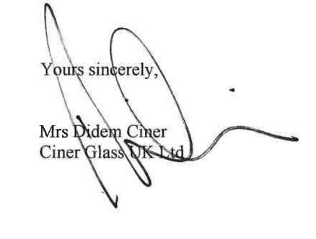

Mrs Didem Ciner
Ciner Glass UK Ltd

